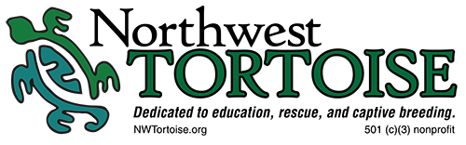
Initial Contact form

Name: ______________________________ Location (city, state):_______________________________
Phone: ________________________ Email address: _________________________________________

Housing type: Own _______ Rent _______ Apartment _______ Condo ________

Will you be able to provide indoor and outdoor enclosures?
Indoor and outdoor _____ Outdoor only _______ Indoor only _______

Experience level:
______ Beginner: never had one
______ Intermediate: 1-10 years of experience keeping one or two
______ Advanced: 10+ years of experience keeping more than one species
Have you ever had a turtle/tortoise before? If yes, do you still have it? If not, what happened to it? What did you learn? Please be specific and honest. Northwest Tortoise will not judge or condemn you for past mistakes.

What species are you looking for? _______________________________ (don’t know, that’s ok!)
Why do you want to adopt a turtle/tortoise?

Please note: This form is for initial contact only. It does not guarantee adoption approval. Additionally, there are no right or wrong answers. Northwest Tortoise works with each individual adopter to match them with a species that fits each situation. If you had a turtle/tortoise in the past and it died, this does not exclude you from adoption. Northwest Tortoise is only interested in what you learned from the situation. Lifetime success is our goal!

